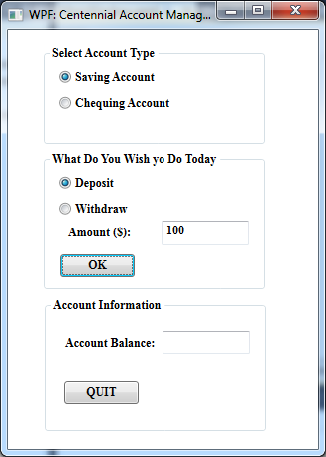

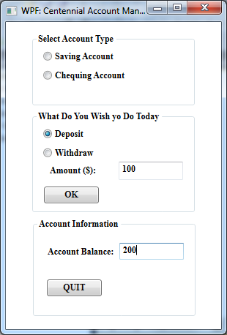

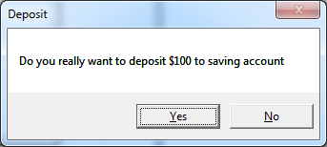

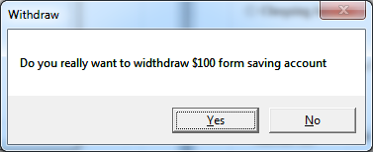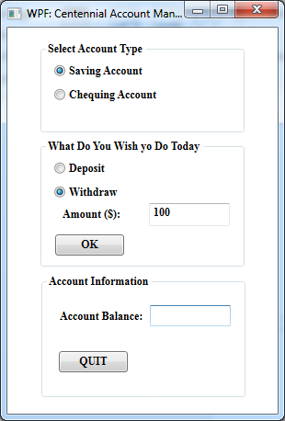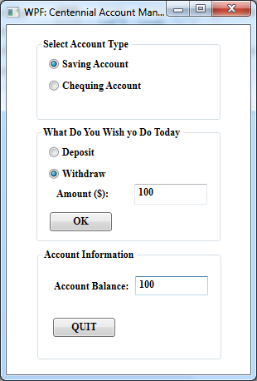

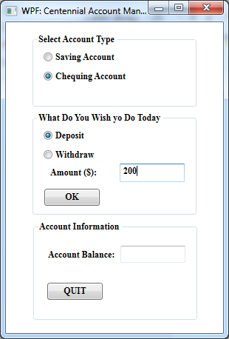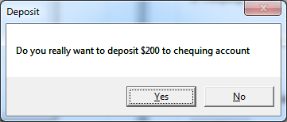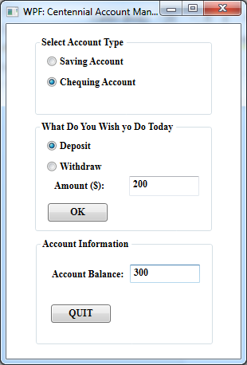

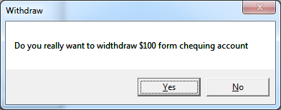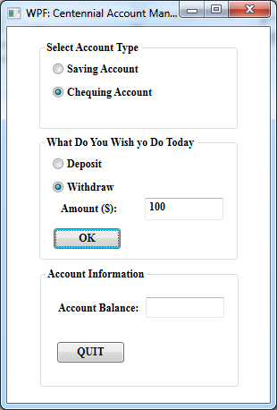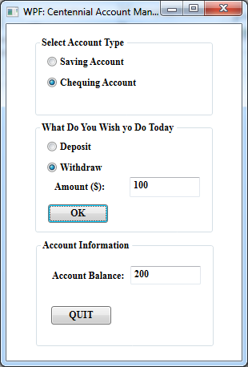

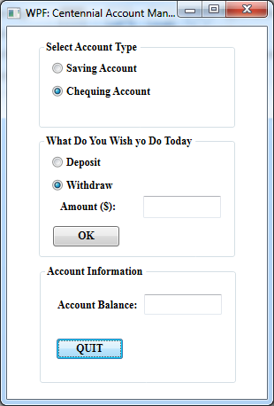

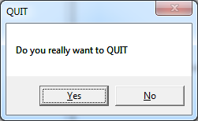

**Coding**

**MainWindow.xaml.cs**

using System;

using System.Collections.Generic;

using System.Linq;

using System.Text;

using System.Windows;

using System.Windows.Controls;

using System.Windows.Data;

using System.Windows.Documents;

using System.Windows.Input;

using System.Windows.Media;

using System.Windows.Media.Imaging;

using System.Windows.Navigation;

using System.Windows.Shapes;

namespace WpfApplication2

{

/// <summary>

/// Interaction logic for MainWindow.xaml

/// </summary>

public partial class MainWindow : Window

{

public bool chequ = false;

public bool saving = false;

public bool deposit = false;

public bool widhtDraw = false;

public static double chequAmt = 100.00;

public static double savingAmt = 100.00;

public MainWindow()

{

InitializeComponent();

}

private void button1_Click(object sender, RoutedEventArgs e)

{

}

private void button1_Click_1(object sender, RoutedEventArgs e)

{

if (chequ && widhtDraw)

{

MessageBoxResult result = MessageBox.Show("Do you really want to widthdraw $"+textBox1.Text+" form chequing account", "Withdraw", MessageBoxButton.YesNo);

if (result == MessageBoxResult.Yes)

{ chequAmt -= Convert.ToDouble(textBox1.Text); }

textBox2.Text = Convert.ToString(chequAmt);

}

else

{

if (chequ && deposit)

{

MessageBoxResult result = MessageBox.Show("Do you really want to EXIT", "Deposit", MessageBoxButton.YesNo);

if (result == MessageBoxResult.Yes)

chequAmt += Convert.ToDouble(textBox1.Text);

textBox2.Text = Convert.ToString(chequAmt);

}

}

if (saving && widhtDraw)

{

MessageBoxResult result = MessageBox.Show("Do you really want to widthdraw $" + textBox1.Text + " form saving account", "Withdraw", MessageBoxButton.YesNo);

if (result == MessageBoxResult.Yes)

savingAmt -= Convert.ToDouble(textBox1.Text);

textBox2.Text = Convert.ToString(savingAmt);

}

else

{

if (saving && deposit)

{

MessageBoxResult result = MessageBox.Show("Do you really want to deposit $" + textBox1.Text + " to saving account", "Deposit", MessageBoxButton.YesNo);

if (result == MessageBoxResult.Yes)

savingAmt += Convert.ToDouble(textBox1.Text);

textBox2.Text = Convert.ToString(savingAmt);

}

}

}

private void radioButton2_Checked(object sender, RoutedEventArgs e)

{

chequ = true;

saving = false;

}

private void radioButton4_Checked(object sender, RoutedEventArgs e)

{

widhtDraw = true;

deposit = false;

}

private void radioButton1_Checked(object sender, RoutedEventArgs e)

{

saving = true;

chequ = false;

}

private void radioButton3_Checked(object sender, RoutedEventArgs e)

{

deposit = true;

widhtDraw = false;

}

private void button2_Click(object sender, RoutedEventArgs e)

{

}

private void button2_Click_1(object sender, RoutedEventArgs e)

{

if (Quit)

{

MessageBoxResult result = MessageBox.Show("Do you really want to QUIT", "QUIT", MessageBoxButton.YesNo);

if (result == MessageBoxResult.Yes)

Environment.Exit(0);

}

}

}

}

**MainWindow.xaml**

<Window x:Class="WpfApplication1.MainWindow"

xmlns="http://schemas.microsoft.com/winfx/2006/xaml/presentation"

xmlns:x="http://schemas.microsoft.com/winfx/2006/xaml"

Title="WPF: Centennial Account Management" Height="458" Width="449" Loaded="Window_Loaded">

<Grid>

<GroupBox Header="Select Account Type" Height="100" HorizontalAlignment="Left" Margin="35,15,0,0" Name="groupBox1" VerticalAlignment="Top" Width="224" FontFamily="Times New Roman" FontStyle="Normal" FontWeight="Bold">

<Grid>

<RadioButton Content="Saving Account" Height="16" HorizontalAlignment="Left" Margin="10,10,0,0" Name="radioButton1" VerticalAlignment="Top" Checked="radioButton1_Checked" />

<RadioButton Content="Chequing Account" Height="16" HorizontalAlignment="Left" Margin="10,36,0,0" Name="radioButton2" VerticalAlignment="Top" />

</Grid>

</GroupBox>

<GroupBox Header="What Do You Wish yo Do Today" Height="140" HorizontalAlignment="Left" Margin="35,121,0,0" Name="groupBox2" VerticalAlignment="Top" Width="224" FontFamily="Times New Roman" FontStyle="Normal" FontWeight="Bold">

<Grid>

<RadioButton Content="Deposit" Height="16" HorizontalAlignment="Left" Margin="10,10,0,0" Name="radioButton3" VerticalAlignment="Top" />

<RadioButton Content="Withdraw" Height="16" HorizontalAlignment="Left" Margin="10,36,0,0" Name="radioButton4" VerticalAlignment="Top" />

<TextBox Height="25" HorizontalAlignment="Right" Margin="0,55,11,0" Name="textBox1" VerticalAlignment="Top" Width="88" />

<Label Content="Amount ($):" Height="28" HorizontalAlignment="Left" Margin="14,55,0,0" Name="label1" VerticalAlignment="Top" />

<Button Content="OK" Height="23" HorizontalAlignment="Left" Margin="11,89,0,0" Name="button1" VerticalAlignment="Top" Width="75" />

</Grid>

</GroupBox>

<GroupBox Header="Account Information" Height="135" HorizontalAlignment="Left" Margin="36,268,0,0" Name="groupBox3" VerticalAlignment="Top" Width="224" FontFamily="Times New Roman" FontStyle="Normal" FontWeight="Bold">

<Grid>

<Button Content="QUIT" Height="23" HorizontalAlignment="Left" Margin="14,69,0,0" Name="button2" VerticalAlignment="Top" Width="75" />

<Label Content="Account Balance:" Height="28" HorizontalAlignment="Left" Margin="10,19,0,0" Name="label2" VerticalAlignment="Top" />

<TextBox Height="23" HorizontalAlignment="Left" Margin="113,19,0,0" Name="textBox2" VerticalAlignment="Top" Width="88" />

</Grid>

</GroupBox>

</Grid>

</Window>